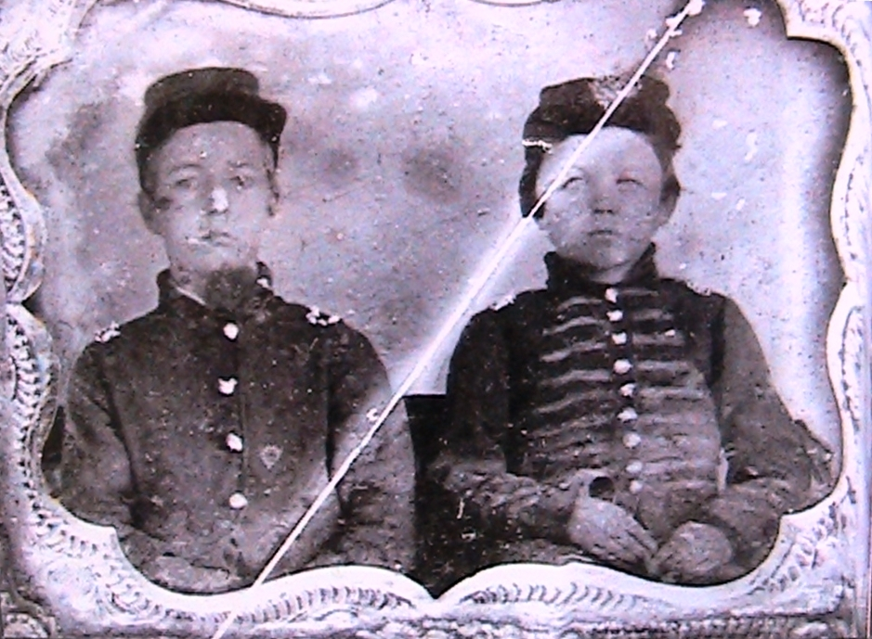
Joseph Eylar, left, and James Morgan of the 59th OVI. Illustration

“The 59th Ohio Volunteer Infantry”

The 59th Ohio Volunteer Infantry Regiment was formed at Camp Ammen in Ripley during October of 1861 to serve three years. Companies C and D were from Brown County and the other eight companies from Clermont. Within days of forming they were sent by riverboat to Maysville to quell an anticipated outbreak caused by the arrest of several prominent southern sympathizers. The appearance of the troops stopped the problem before it started. After the trouble was over, the regiment was trained at Camp Kenton near Maysville.
At 8 PM, on April 6th 1862 the 59th had reached the Tennessee River after a long days march. At 10 PM the regiment was aboard the steamboat “John J. Roe” bound for Pittsburg Landing, Tennessee. The battle had raged all day around Shiloh Church. At midnight they had reached the field and were in line of battle. On the 7th they engaged the enemy all day. They lost 9 killed and 49 wounded.
After the battle of Shiloh the 59th was in the advance to Corinth and then as part of the Army of the Cumberland fought at Stone’s River on December 31-January 2, 1863 with heavy losses. As winter turned to spring the 59th marched south of Chattanooga and were in camp near a stream the Indians had named “Chickamauga”, the “Stream of Death”. On September 18, 1863 at 10 PM the 59th had the honor of opening to battle to follow. The battle raged on for two days and eventually the Union forces were pushed back to Chattanooga with great losses.

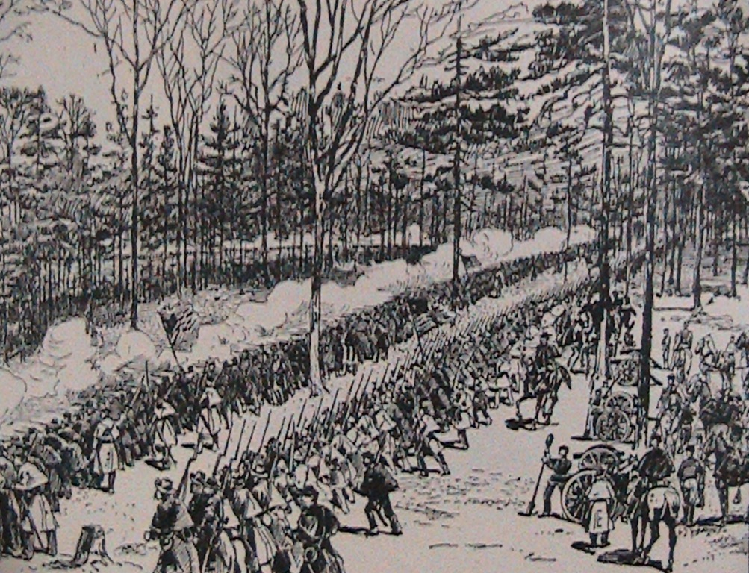
59th hold the line at Stone’s River. Illustration 32

General Grant took command at Chattanooga in October and on November 25th the Battle of Mission Ridge began. The 59th was part of Gen. Wood’s Division that was to act as a diversion in the center of the line below the 700 foot ridge. They marched with bands and flags at first, the Confederates cheered the pageantry from their lofty defenses, and then the 59th and the rest of the Army of the Cumberland rushed the Confederate rifle pits at the base of the ridge. The Confederate riflemen fled in disbelief. Now the 59th had reached their objective but they soon realized they couldn’t stay there. The fire from above was deadly. They had no orders to retreat but they also had no orders to advance. No one knows who started up the steep ridge first but up the hill they went.
Gen. Grant saw the advance and asked their commander, Gen Thomas, “Who gave the order to advance?” Thomas replied that he hadn’t and didn’t know who had but said he would find out. Gen. Grant said, “Wait a moment and let’s see what happens.” The Confederate defensive position atop the ridge was considered by both sides to be impenetrable. The men going up the hill didn’t consider that. They just clawed and scratched their way up the wooded ridge. A flag moved ahead then fell; soon it was picked up and moved higher. First one group and then another advanced but when the crest was reached it was the 59th that had won this desperate race. The Confederate defenders broke and ran. One man of the 59th jumped on the barrel of a rebel cannon like it was a horse and was burned so badly he was in the hospital for months. William C. Thompson, color bearer of the 59th, was killed as he planted the colors beside a cannon.
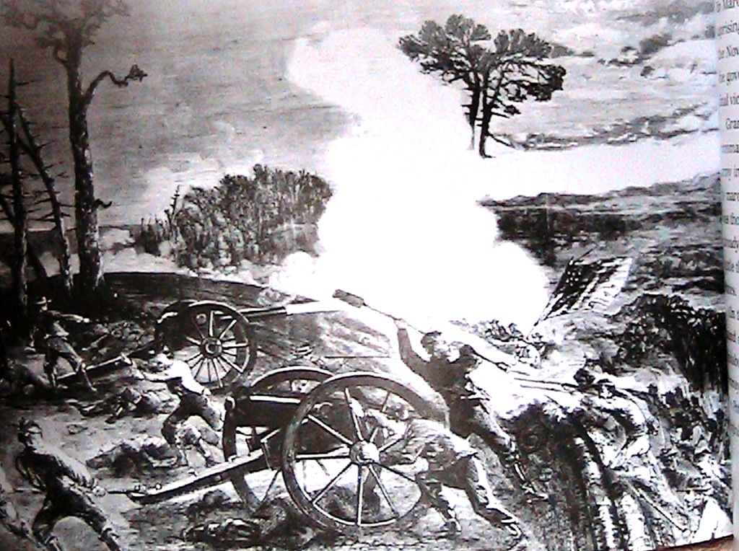
59th OVI reaches the crest of Mission Ridge first. Illustration 33

The “Fighting 59th” would join Gen. Sherman’s Atlanta Campaign and fight at Rocky Face Ridge, Resaca, Dallas, New Hope Church, Kennesaw Mountain, Peach Tree Creek and the battles around Atlanta.

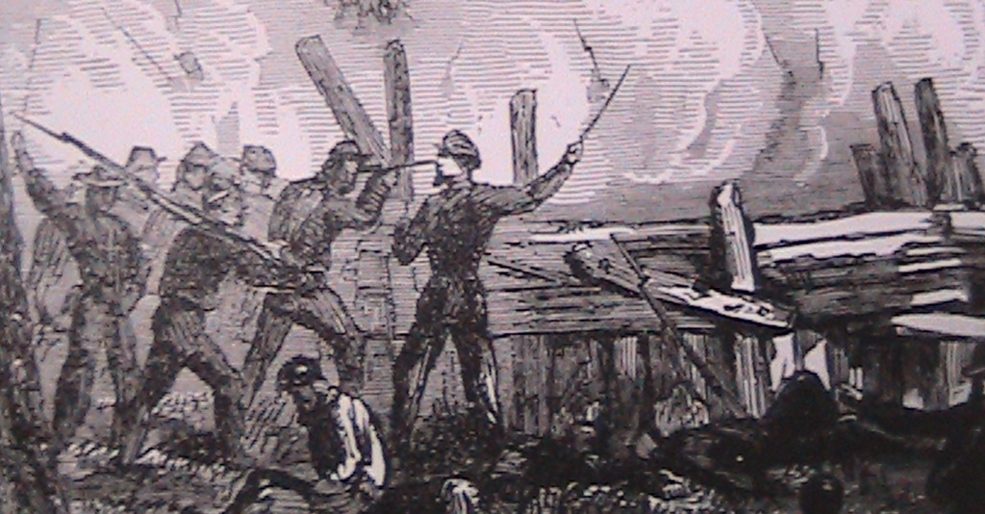
The 59th at the Battle of Kennesaw Mountain. Illustration 34

The regiment was so depleted by November 1st of 1864 that they only had enough veterans to reenlist to form a battalion of two hundred men. They were sent to Nashville where they served out the war as Companies I & K of the 189th OVI.
One of the veteran members of the 59th that went into the 189th was 14 year old drummer boy, James Morgan, of Georgetown, (pictured on to right) who served the entire war. Joseph W. Eylar, 13 years old, also of Georgetown, went to war because his father took a job as a teamster for the 59th and his son simply went along. In the winter of 1863 the Eylars were in a party that was to carry dispatches to Gen. Burnside at Cumberland Gap and were nearly captured. The elder Eylar decided that the front might not be the safest place for his son and he sent him back to Brown County. In 1890, Joseph W. Eylar purchased an interest in the News-Democrat and was its editor until his death in 1906.
Sophia Thompson served three years in the 59th O. V. I. under the name of Joseph Davidson. She served three years in the same company. She volunteered after her brother was killed in the war. Her father was killed fighting by her side at Chickamauga. She was not discovered until she applied for a pension after the war.
The regiment lost 6 officers and 70 enlisted men in battle and 134 men to disease.



